Name ___________________________
Each of the following has one or more errors. Find the errors, circle or mark them, and correct them.
1)
VA:
HA:
Zero: 1, -3
Oblique Asymptote: none

2) Graph
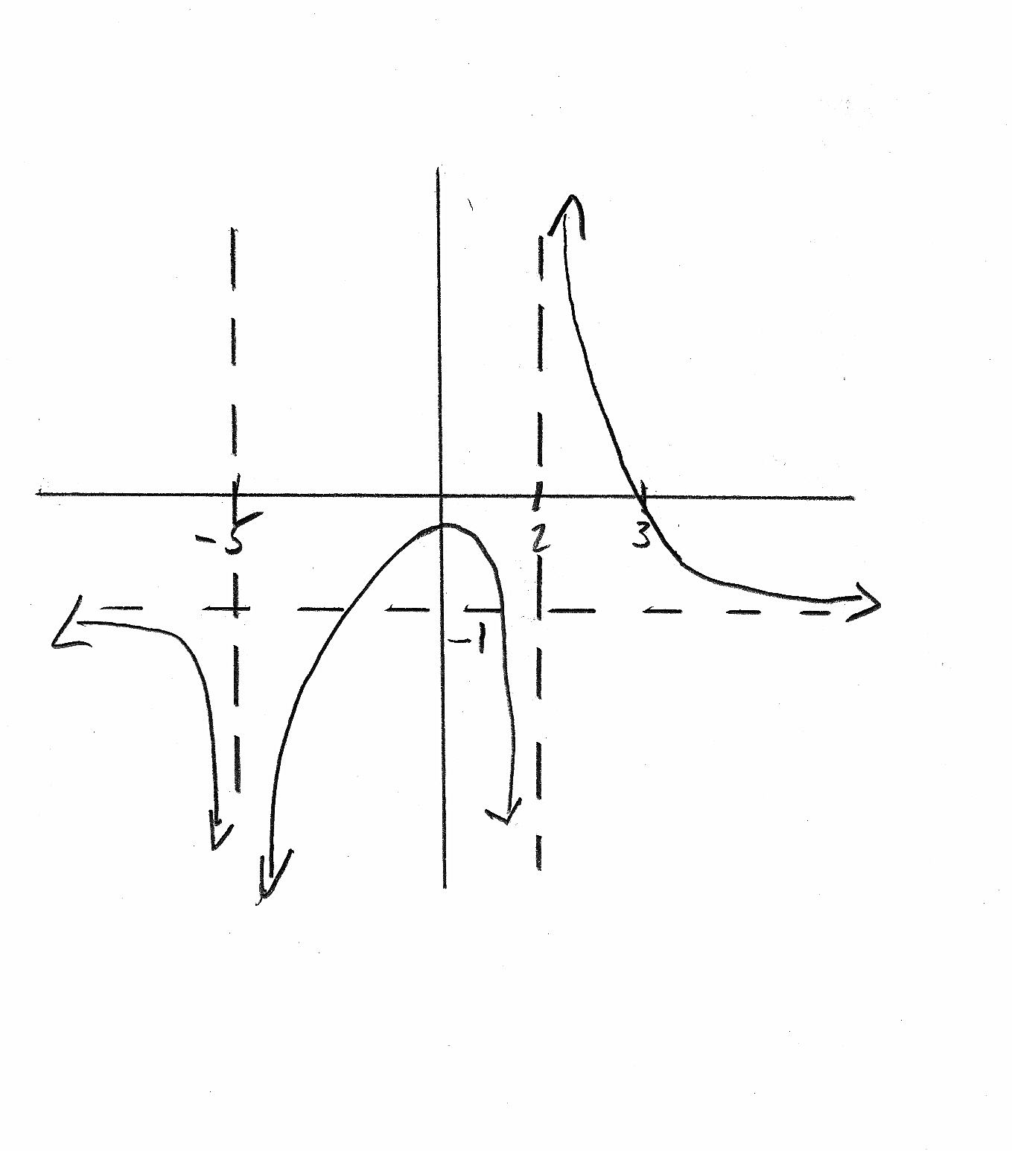

3) Given the graph, state its rule.
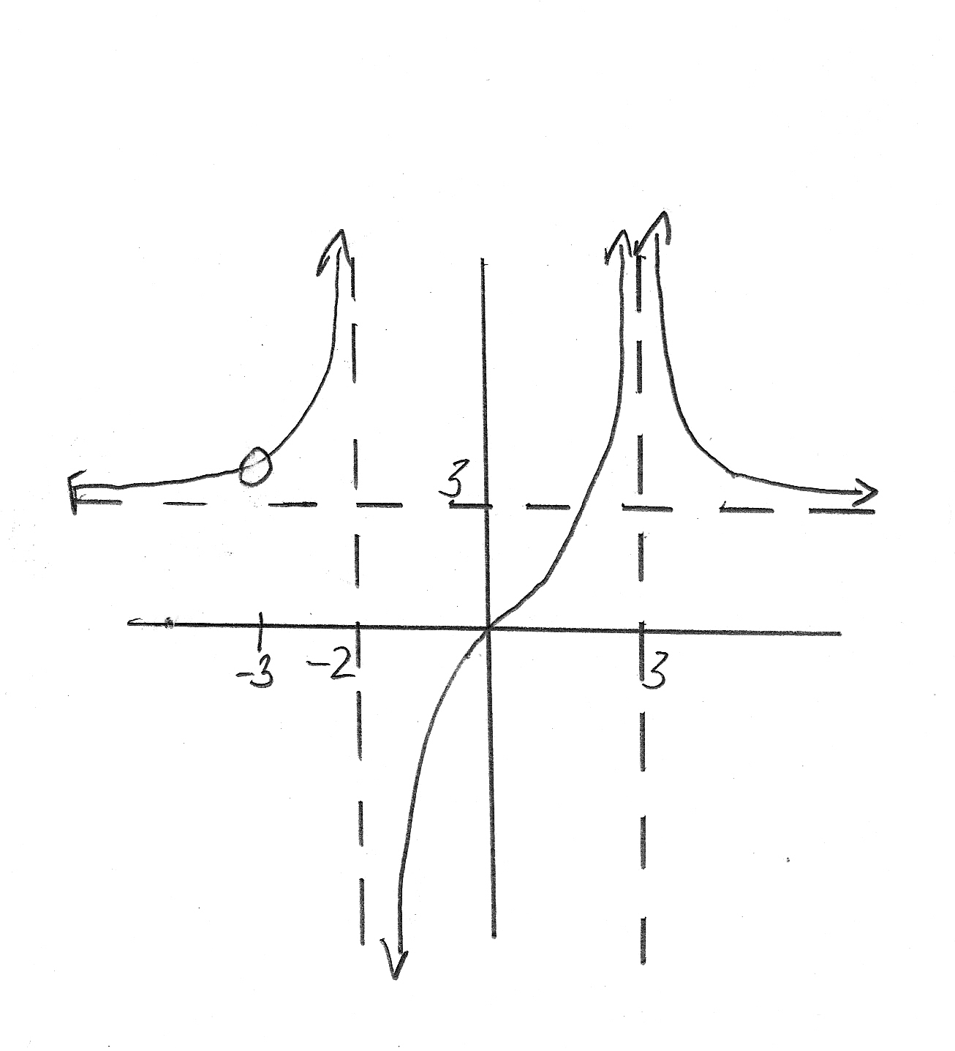

4) Given the graph, graph its reciprocal. Original graph has the thicker line.
